Vendor Business License Application
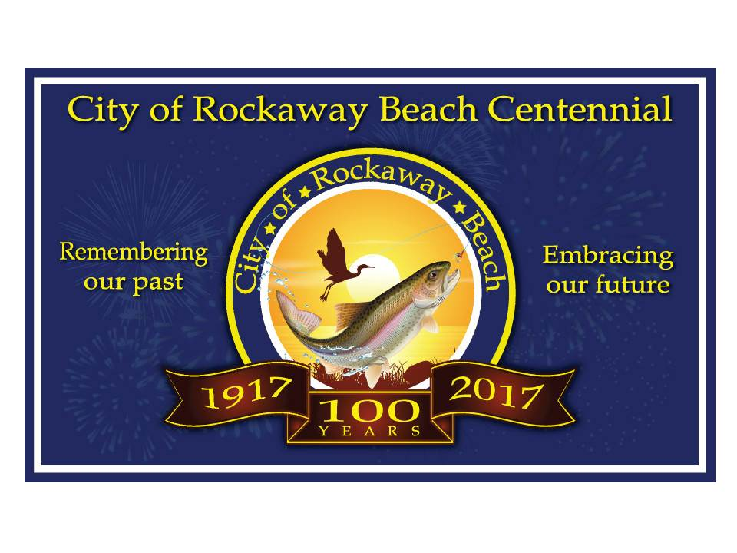
City of Rockaway Beach, MO
PO Box 315
Rockaway Beach, MO 65740
417-561-4424

Date of Application_____________

Business Name:______________________________________________________________________

Business or Home Phone:_______________________ Cell Phone: ____________________________

Missouri State Sales Tax License #_______________________________ (Please attach Copy of License)
Also Please attach a copy of Liability Insurance if you are offering amusement rides.
Mailing Address
of Business: ___________________________________________________________________________

City: ______________________________________________ State:_______ Zip:__________________

911 Address:__________________________________________________________________________

Email Address: ________________________________________________________________________

Owners:
Name _________________________________________ SSN# XXX-XX- ____ ____ ____ ____

Name _________________________________________ SSN# XXX-XX- ____ ____ ____ ____

Type of Business: ______________________________________________________________________

Type of Event(s): _______________________________________________________________________

Vendor’s Fees
Choose One:
Total City of Rockaway Fees

License Fee + $__________

Electric Fee + $__________
_________________________

Total of Fees $___________
Attach Check for Above Amount to:
The City of Rockaway Beach
- $5.00 License for one event
- $25.00 License for one year
(Best Value for 5 or more events a year.)
Choose One:
- Electric Use Fee 110 Service $15.00 per event
- Electric Use Fee 220 Service $25.00 per event
- No Electric Needed
Under Oath, I affirm that I do not and shall not employ any person who does not
have the legal right or authorization under Federal Law to work in the United States.

__________________________________ Date _____________
Vendor Signature

___________________________________Date ______________
City of Rockaway Beach Representative Approval _________________

Vendor Permit Requirements
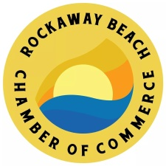
City of Rockaway Beach, MO
PO Box 315
Rockaway Beach, MO 65740
417-561-4424

Anyone setting up a booth, trailer or table space to conduct sales or providing amusement type entertainment during approved special events or as an individual event in Rockaway Beach must purchase a Booth space with the Chamber of Commerce. And a Temporary Business vendor’s license at the Rockaway Beach City Hall, 2536 State Hwy 176, Rockaway Beach, MO, 65740.

5 Days prior to your event You will need to provide:
A copy of your Missouri Sales Tax license or proof of tax exemption if you are a non-profit organization. (if you have a tax license.)

A copy of your Current Taney County Health certificate if a food vendor and copy of Liability insurance

If Electricity is needed for the time of the event, please include amount for Electricity with your Temporary Vendors Business License amount.
$15 per 2 consecutive day’s event for 110v
$25 per 2 consecutive day’s event for 220v
$5 per event Vendor’s license or $25 per year Vendor’s license
A separate check made out to the City of Rockaway Beach for any fees required for your Vendor’s business License and Electricity usage.
Booth space fees are paid separately to Rockaway Beach Chamber of Commerce. Memo: 4th of July

$1,000,000 (One Million Dollars) in liability insurance if you are offering amusement rides or Food Vendor.

All of the pertinent items above must be presented to the Rockaway beach Chamber of Commerce before any vendors license is approved and issued.

We appreciate your participation in our events. All questions can be directed to our staff at the Chamber of Commerce or Rockaway Beach City Hall.

Thank You
Rockaway Beach Chamber of Commerce

